SOP ID - Number | HR03-P01
Revision | 6
SOP Title | Internal Job Posting

 | Name | Title | Signature | Date
Prepared by | Bashar Haddad  Lara Awaimreen | HR Specialist |  | 16/01/2025
Reviewed by | Zaid Ibrahim | HRBP |  | 17/01/2025
Approved by | Bishara Shemali | S.HR Manager |  | 20/01/2025

Effective Date
Review Date
Next Review Date
Print Date

Read/Used By
Name | Title | Signature | Date
- purpose
Wuduh is committed to providing employees with opportunities to grow, explore different roles, and advance their careers. As part of this commitment, the Job Posting Program (ZenHR) supports succession planning by identifying and developing talent to ensure the continuity and growth of the organization.
- Scope
This Policy and Procedure applies to all employees who have successfully completed their probation period
- Policy
- All internal applications must be submitted through the ZenATS portal.
- Internal employees are notified through ZenHR announcements and emails for any available vacancies.
- Internal candidates are subjected to eligibility criteria, only employees who meet the minimum requirements outlined in the job posting are eligible to apply:
  - Tenure: Determined by HR based on the role weight and job level
  - Disciplinary actions/warnings: Active disciplinary actions disqualify candidates for 3 months and warnings for 6 months.
  - Recent promotions: Recent promotions and movements disqualify candidates within 3 months of the active date.
  - Undergoing performance improvement plan (PIP)
- Internal candidates who provide false information during the application process will face disciplinary action and may be disqualified from applying to any Internal Job Posting (IJP) openings for the next six months.
- Internal candidates must have passed a performance appraisal conducted by the QA department and successfully completed a technical test for the posted vacancy, administered by the L&D & Hiring Manager.
- Any applications from employees who do not meet these criteria will be automatically disqualified.
- All eligible internal candidates will be considered fairly for the role, and the decision-making process will be based on merit, qualifications, and past performance.
- Once the selection process is complete, all internal candidates who applied will be notified of the decision, regardless of the outcome.
- In special cases where there are no suitable internal candidates after the initial posting period, the job posting may be extended internally or opened to external applicants, as necessary.
- The IJP process must be initiated by the Workflow Team for operational positions and by the respective hiring manager for Support Functions.
- All selected and shortlisted candidates must be interviewed by the hiring manager. If a qualified candidate is rejected, the hiring manager is required to provide a justification for the decision.
- Any employee transferred or promoted through the IJP process for a vertical position must be assessed by the hiring manager after three months, with the results communicated to the HR Department. For promoted employees, any financial impact will be updated on ZenHR and a letter outlining the change is communicated through ZenHR.
- Two (2) days of training are required for the selected employees for team leads roll and above.
- If the employee does not meet performance expectations within three months, they will be transferred back to their previous position.
- The employee must be enrolled in the ARMADA project if the IJP process results in a vertical promotion from one position to a higher one, in accordance with ARMADA policies and procedures.
- As part of the IJP process, priority will be given to employees who have successfully participated in relevant IDP or IJP workshops. These employees will be considered for fast-tracking in the promotion process, as their involvement in these workshops demonstrates their commitment and readiness for advancement.
- Definitions AND ABBREVIATION
- Transfer: Moving an employee from one position to another at the same level (horizontal move) without any financial impact.
- Promotion: Advancing an employee to a higher position (vertical move) with a salary increase in accordance with the compensation and benefits system.
- ARMADA: an initiative focused on standardizing and optimizing KPIs, processes, and performance tracking across all operational departments. It serves as the ultimate reference for HR, Marketing team and Operations Heads in taking decisions related to the employee’s growth and career opportunities.
- HRS: Human Resources Specialist
- IJP: Internal Job Posting
- WFT: Workflow Team
- IC: Internal Candidates
- HM: Hiring Manager
- SF: Support Functions
- ROLES AND responsibilities
Hiring Manager (HM)
- Submit IJP request to WFA for operations related vacancies.
- Submit IJP request to HRS for support functions vacancies.
- Provide relevant vacancy details and job descriptions to HRS for job posting preparation.
- Select the final candidate after interviews and share the decision with HRS.
HR Specialist (HRS)
- The HRS is responsible for the IJP process and ensures all steps are followed.
Workflow Team (WFT)
- Assist in validating the vacancy once the request is submitted by the HM.
- Determine which pool the HRS can target to avoid operation complications.
- Provide support in ensuring budget approval from the Finance Department is in place before moving forward according to the operations director recommendation.
Quality Assurance (QA) Department
- conducting thorough assessments to evaluate candidates' qualifications and performance. This includes reviewing their past performance, ensuring they meet the necessary criteria, and identifying those who are best suited for the role.
Learning & Development (L&D) Department
- the L&D department is responsible for assessing candidates' suitability by evaluating whether their skills align with the position's requirements through a series of survey questions and related assessments.
- SPECIFIC PROCEDURE

6.1. Internal Job Posting “IJP” Request approval.
The HRS will receive the IJP request from the Hiring/Department Manager (HM), and validate the vacancy with the Workflow Team (WFT). If the request is submitted directly by the WFT, no further validation is needed. In both scenarios—whether the request is from HM or WTF —it must be in line with the approved budget.
6.2. Job Posting Preparation
    - Once the IJP request has been approved and validated, HRS will create a new IJP for three (3) days with clear and concise summary of the requisition details, including the number of vacancies for each role, Job Descriptions on ZenATS. The posting will also outline the eligibility criteria for candidates, the required qualifications, and any other relevant requirements to ensure applicants fully understand the expectations. Additionally, the HR questionnaire will be included as part of the posting to ensure that all applicants meet the necessary qualifications for the role.
    - HRS will post an announcement on ZenHR regarding the IJP opening to inform the employees and start applying for the vacancy.
6.3 First round shortlist “HR”

    - The HRS will review all incoming applications and create a shortlist of candidates who meet the required criteria. This step involves evaluating the employee’s length of service, previous performance, and adherence to company policies
    - If an internal candidate does not meet the eligibility requirements, the HRS will update their status in ZenATS as "unqualified." And send an automated email with disqualification reason, If the candidate qualifies, the HRS will inform the Quality Assurance (QA) Department that the HR shortlist is ready to be checked on ZenATS.
6.4. Second Round Shortlist “QA”

    - The QA Department will evaluate the shortlisted candidates on ZenATS based on their performance over the past 3 months or the data available for candidates to determine their suitability for the position.
    - If the candidate meets the average quality score, the QA Dept. will share the qualified candidates on a ZenATS and notify the HRS to coordinate the next round assessment by the L&D Department.
    - If a candidate does not meet the average quality score the QA Manager will disqualify the candidate on ZenATS and send an automated email with disqualification reason and notify the HRS with the results.
6.5. Third Round Shortlist “L&D”

    - The L&D Department will conduct an assessment to evaluate the suitability of the candidate for the posted role. This will be done through a set of survey questions designed to assess whether the candidate’s skills align with the requirements of the position.
    - If the candidate meets the performance assessment, the L&D will update the list of qualified candidates on ZenATS and inform the HRS accordingly to coordinate with the Hiring Manager for a final interview.
    - If the candidate does not pass the required performance assessment, the L&D coordinator will disqualify the candidate on ZenATS and send an automated email with disqualification reason and share the results with the HRS.
6.6. Fourth Round “Hiring Manager Interviews”

    - The HRS will share the list of shortlisted candidates with the Hiring Manager through ZenATS and E-mail after validating the HR requirements through ZenHR, in accordance with the above policy number three.
    - The HRS will initiate the "Book-My-Calendar" process for all shortlisted candidates where the hiring manager provides a link with available interview slots to the HRS to be shared with successful candidates.
    - The HRS will request the hiring manager to provide additional 20% interview slots than the number of shortlisted candidates to ensure candidates have greater flexibility and convenience in choosing suitable time slots.
    - The HRS will notify the selected candidates and provide them with a Book-My-Calendar invitation link.
    - The Hiring Manager will conduct the interviews and if the candidate(s) are selected, the Hiring Manager will email the names of the selected candidates to the HRS. The HRS will then contact the candidates' current managers to obtain transfer/promotion approval and address any concerns regarding the joining date
    - For Operations Team lead and above roles, as well as non-operational "Fifth Floor" positions, the Hiring Manager and HRS will conduct interviews jointly. If candidates are selected, the Hiring Manager will email the selected names to the HRS. The HRS will then coordinate with the candidates' current managers to obtain transfer/promotion approval and finalize the joining date.
6.7. Fifth Round “Transfer/ Promotion process”
- If the Transfer “horizontal move” is approved, the HRS will update the candidate's professional details (e.g., title, reporting line, shift/hours) in ZenHR and issue a transfer letter.
- If the candidate is promoted for a higher role “vertical move”, the HRS will update the candidate’s professional details (e.g., title, reporting line, shift/hours) in ZenHR and issue a promotion letter. After 3 months of successful service in the new role, the HRS will initiate the salary increase process. According to ARMADA policy and procedure.
- The HRS will coordinate with the hiring manager and the current manager to finalize the transfer date. In collaboration with the IT, L&D and Facilities departments, HRS will ensure that all required equipment and workspace are fully prepared for the employee's new role prior to the transfer.
- The HRS will send the rejections letters to all disqualified candidates after closing the IJP

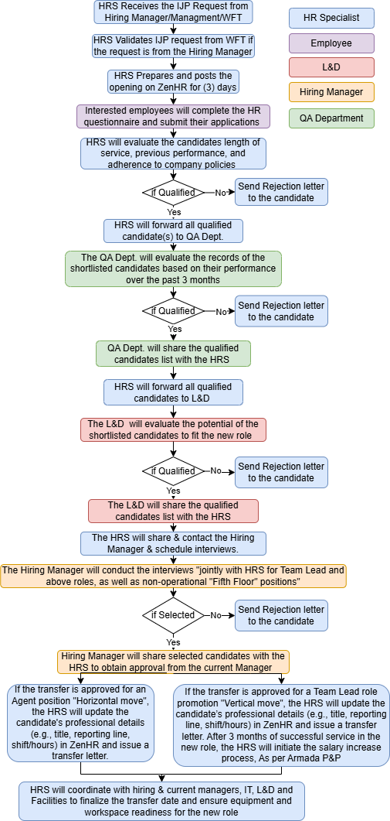

forms/Templates to be used

documentations AND RECORDS

internal and external references

  - Book My Calendar link: https://outlook.office.com/bookwithme/
  - Book my Calendar orientation: https://www.youtube.com/watch?v=GkWgw-lnVhA

Legal and Regulatory Compliance

Documentation and Records

REVISION AND Change History

SOP No. | Effective  Date | Significant Changes | Previous  SOP No.

IJPs FAQ:
- I haven't received the IJP link.
Please check the notifications on your ZenHR, where you will find an announcement containing the link. Each announcement remains active for 3 days.
- I haven't received any feedback.
It's likely that the HRS are still in the process of reviewing applications. You will receive feedback once the process is complete, whether it's acceptance or rejection.
- My application didn't go through.
Ensure you applied within the given time frame. If you're unsure, contact the HRS for assistance and they will guide you.
- I haven't received a transfer letter for the acting period.
Please check your email inbox. The transfer letter will be sent once the HRS has completed the process.

